Name: Majid Ali
CMS ID: 053-25-0017
Course: Java (Lab: 8)

Task No: 1

class Laptop {
String brand;
Laptop(String brand) {
this.brand = brand;
}
String getBrand() {
return brand;
}
}

class Teacher {
String name;
Laptop laptop;

Teacher(String name) {
this.name = name;
this.laptop = null;
}

void setLaptop(Laptop l) {
this.laptop = l;
}

void displayInfo() {
System.out.println("Teacher Name: " + name);
if (laptop != null) {
System.out.println("Laptop: " + laptop.getBrand());
} else {
System.out.println("No laptop");
}
}
}

public class Main {
public static void main(String[] args) {

Laptop lap1 = new Laptop("Dell");
Teacher t1 = new Teacher("Ali");

t1.setLaptop(lap1);
t1.displayInfo();

System.out.println("----- After removing laptop -----");

t1.setLaptop(null);
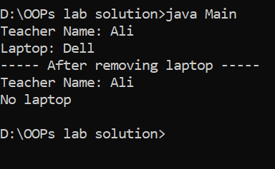
t1.displayInfo();
}
}

Task No: 2

class Player {
String name;

Player(String name) {
this.name = name;
}

String getName() {
return name;
}
}

class Team {
String name;
Player[] players;
int count;

Team(String name, int maxPlayers) {
this.name = name;
players = new Player[maxPlayers];
count = 0;
}

1
void addPlayer(Player p) {
if (count < players.length) {
players[count] = p;
count++;
} else {
System.out.println("Team is full!");
}
}

String getTeamName() {
return name;
}

void displayPlayers() {
System.out.println("Team: " + name);
for (int i = 0; i < count; i++) {
System.out.println("Player: " + players[i].getName());
}
}
}

public class Main {
public static void main(String[] args) {

Player p1 = new Player("Babar");
Player p2 = new Player("Rizwan");
Player p3 = new Player("Shaheen");
Team team = new Team("Pakistan", 10);
team.addPlayer(p1);
team.addPlayer(p2);
team.addPlayer(p3);
System.out.println("Team Name: " + team.getTeamName());
team.displayPlayers();
}
} 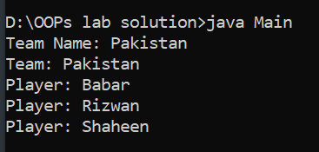

Task No: 3

class CPU {
String model;

CPU(String model) {
this.model = model;
}
String getModel() {
return model;
}
}
class Computer {
String brand;
CPU cpu;
Computer(String brand, String cpuModel) {
this.brand = brand;
this.cpu = new CPU(cpuModel);
}
String getComputerInfo() {
return "Brand: " + brand + ", CPU: " + cpu.getModel();
}
void start() {
System.out.println("Computer started with CPU: " + cpu.getModel());
}
}
public class Main {
public static void main(String[] args) {
Computer c1 = new Computer("Dell", "Intel i5");
System.out.println(c1.getComputerInfo());
c1.start();
}



